BSCS FINAL PROJECT PROPOSAL

StyleSense.AI: A Cloud-Based Intelligent Outfit Recommendation System

Term of Registration: Fall 2022



Presented by:

Registration No: | Name:
L1F22BSCS1098 | Muhammad Usman
L1F22BSCS1125 | Umair Akram
L1F22BSCS1116 | Muhammad Abbas

Faculty of Information Technology
University of Central Punjab

Project Title
StyleSense.AI: A Cloud-Based Intelligent Outfit Recommendation System

Project Advisor
Professor Tauseef Hanif

Particulars of the students:
S.No | Registration#  eg.L1F00BSCS0101 | Name in Full  Use Block Letters | CGPA | Signatures
1 | L1F22BSCS1098 | Muhammad Usman | 2.26
2 | L1F22BSCS1125 | Umair Akram | 2.08
3 | L1F22BSCS1116 | Muhammad Abbas | 2.18

Advisor’s Consent

I Prof./Dr./Mr./Ms. Professor Tauseef Hanif am willing to guide these students in all phases of above-mentioned project as advisor. I have carefully seen the Title and description of the project and believe that it is of an appropriate difficulty level for the number of students named above.

Note:  Advisor can’t be changed without prior permission of the Manager Projects and the duration for completion of the Project is 2 regular semesters (approx.) from the date of Registration of Research Project. | Signatures and Date  Advisor

EVALUATOR/REFEREE 1
I have carefully read the project proposal and feel that the proposed project is a useful one and of a sufficient difficulty level to justify 2 regular semesters workload for above mentioned students. I have made recommendations in the evaluation form to improve the scope and quality of the project.

Signatures and Date
EVALUATOR/REFEREE 2
I have carefully read the project proposal and feel that the proposed project is a useful one and of a sufficient difficulty level to justify 2 regular semesters workload for above mentioned students. I have made recommendations in the evaluation form to improve the scope and quality of the project.

Signatures and Date

Abstract / Executive Summary
StyleSense.AI is a cloud-based intelligent outfit recommendation system designed to simplify the process of selecting stylish and appropriate clothing. Unlike existing solutions, it integrates advanced features such as body-shape detection, wardrobe digitization, AR try-on, weather-based suggestions, and calendar syncing within a single scalable platform. The system leverages cloud infrastructure to ensure secure data storage, cross-device availability, and real-time performance. Potential risks such as privacy, cloud dependency, and user adoption are mitigated through encryption, redundancy, and anonymization. By combining innovation, practicality, and robust deployment, StyleSense.AI provides a unique solution for modern, personalized fashion management.

Introduction and Background
Fashion personalization is becoming increasingly important as users seek smart solutions to match their lifestyle, body type, and preferences. While multiple outfit recommendation applications exist, they are limited by generic suggestions, lack of integration with personal wardrobes, or absence of body-shape adaptation. With advancements in AI, cloud computing, and AR technologies, it is now possible to create a highly interactive system that delivers precise and personalized outfit suggestions. StyleSense.AI leverages these technologies to bridge the gap between existing solutions and user needs, offering a modern platform for smart fashion assistance.

Statement of the Problem
Existing outfit recommendation systems fail to provide comprehensive personalization and accessibility. They often lack body-shape-based styling, do not support wardrobe digitization, and rarely integrate external factors such as weather or events. Moreover, many are not deployed on cloud infrastructure, limiting scalability and multi-device usability. These gaps create the need for a secure, scalable, and user-centric solution that addresses personalization, practicality, and accessibility in one system.

Objective(s) / Aim(s) / Target(s)
- To design and develop a cloud-based intelligent outfit recommendation system.
- To enable users to create a virtual wardrobe by uploading their clothing items.
- To integrate body-shape detection for personalized styling.
- To incorporate real-time weather data and calendar syncing for context-aware suggestions.
- To implement AR-based virtual try-on for better visualization.
- To ensure security, scalability, and cross-device availability through cloud deployment.

Completeness Criteria
- Algorithm Development (40%) remains the most critical component, as it powers the personalized outfit recommendations based on body shape and contextual information (weather, calendar).
- Cloud Infrastructure (15%) is essential for the scalability of the platform, ensuring the website can handle large amounts of data and users in real-time.
- Web Application Development (10%) is crucial for creating a user-friendly, intuitive interface.
- AR Integration (10%) is a significant differentiator, enabling users to try on clothes virtually.
- Communication Features (5%) focus on enhancing user engagement, including social sharing and feedback.
- Security & Privacy (10%) is critical to maintaining trust with users by protecting their data and ensuring safe online interactions.

S.No. | Criteria | Weightage %
1 | WebApplication Development | 10
2 | Algorithm Development | 40
3 | Cloud Infrastructure & Deployment | 15
4 | Augmented Reality (AR) Integration | 10
5 | Communication Features | 5
6 | Security & Privacy | 10

Challenges
- Accurate body-shape detection while preserving user privacy.
- Encouraging user adoption despite hesitation in uploading personal data.
- Seamless integration of AR technology for virtual try-on.
- Real-time cloud synchronization with minimal latency.
- Handling scalability for multiple users simultaneously.

Knowledge Areas Required
- Artificial Intelligence & Machine Learning (recommendation algorithms, computer vision).
- Cloud Computing (deployment, scalability, security).
- Mobile & Web Development (cross-platform interfaces).
- Augmented Reality (virtual try-on feature).
- Cybersecurity (data encryption, secure authentication).

Learning Outcomes
- Ability to design AI-based recommendation algorithms.
- Hands-on experience with cloud deployment and integration.
- Proficiency in AR application development.
- Understanding of data privacy and risk management strategies.
- Improved skills in mobile/web app development and API integration.

Nature of the End Product / Research Outcomes
The final product will be a cloud-deployed application accessible via desktop and mobile platforms. It will allow users to maintain a virtual wardrobe, receive personalized outfit recommendations, try on outfits virtually using AR, and plan looks based on weather and events. The system will serve as a research contribution by demonstrating how AI, AR, and cloud computing can be combined to create a secure and scalable fashion recommendation platform.

Related Work / Literature Survey / Literature Review
Several applications like Stitch Fix, Amazon Personal Shopper, and Fashwell provide fashion recommendations, but they are either limited to curated shopping or lack real-time personalization. Academic research has focused on AI-based fashion compatibility models, wardrobe matching algorithms, and clothing retrieval systems. However, integration of multiple factors—body type, wardrobe digitization, AR try-on, weather, and events—remains underexplored. StyleSense.AI differentiates itself by providing an all-in-one cloud solution that addresses these gaps.

Deliverables / Work Breakdown Structure

- Requirement Analysis and System Design
- Literature review, feature selection, system architecture.
- Algorithm Development
- Outfit recommendation engine, body-shape detection.
- Cloud Infrastructure Setup
- API integration (weather, calendar), database deployment.
- Front-End Development
- Mobile app and desktop GUI for user interaction.
- Augmented Reality Integration
- Virtual try-on feature.
- Testing and Risk Mitigation
- Security, usability, and scalability testing.
- Final Deployment and Documentation
- Cloud launch, user manual, final FYP report.

Project Plan / Project Schedule / Project Timetable / Project Calendar
- The project will be executed in two semesters (approx. 1 year).
- Semester I (Months 1–4)
- Requirement analysis, literature review, and system design.
- Dataset collection for clothing, body-shape, and fashion trends.
- Prototype of recommendation algorithm (basic outfit matching).
- Design of desktop/web GUI.
- Semester II (Months 5–8)
- Advanced algorithm development (body-shape detection, weather/event integration).
- Development of mobile application.
- Cloud deployment and API integrations (weather, calendar, social media).
- Implementation of AR try-on module.
- Testing, evaluation against completeness criteria, risk mitigation.
- Final documentation, report writing, and FYP defense preparation.

Resources Required

- Hardware Resources
- Development laptops/desktops (with GPU preferred for AI model training).
- Smartphones (Android/iOS) for testing the mobile app.
- Software Resources
- Programming languages: Python (AI/ML), JavaScript/React/Flutter (frontend & mobile).
- Frameworks: TensorFlow/PyTorch (ML), OpenCV (vision), ARCore/ARKit (AR).
- Cloud Platforms: AWS / Azure / Google Cloud (for deployment).
- Databases: Firebase, MongoDB, or PostgreSQL.
- API Integrations: Weather API, Calendar API, Social media APIs.
- Human Resources
- FYP team members (developers, testers).
- Supervisor guidance.
- Optional: consultation with fashion experts for dataset and style rules.

Miscellaneous
- Risk Management:
- Data privacy → encryption & anonymization.
- Cloud dependency → multi-region deployment.
- Adoption hesitation → local previews before cloud upload.
- Ethical Considerations:
- Ensure user data (photos, wardrobe items) is handled securely.
- Provide transparency in recommendations (no biased suggestions).
- Future Scope:
- Integration with e-commerce platforms (buy suggested outfits).
- AI chatbot for personalized fashion advice.
- Outfit rating and feedback system to refine recommendations.
- Expansion into smart mirrors and wearable tech integration.

Abstract Story Board and Identification of Characters (For Game-Oriented Projects Only)
Provide some details about the game you are developing.

Sketch of Proposed Solution (For Research-based and Hardware-
Oriented Projects Only)

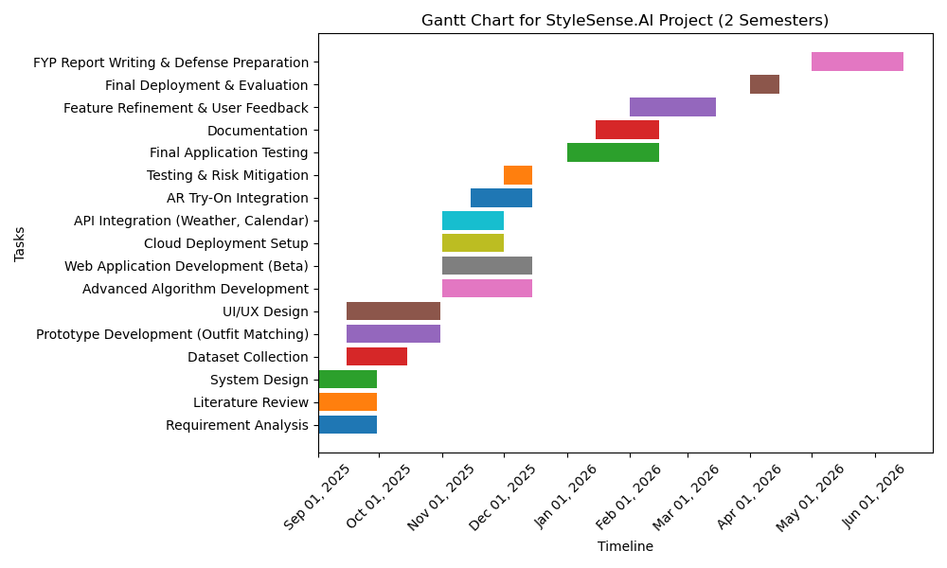

References/Bibliography
- Stitch Fix, “Stitch Fix,” [Online]. Available: https://www.stitchfix.com. [Accessed: Sept. 14, 2025].

- Fashwell, “AI for fashion – Fashwell,” [Online]. Available: https://www.fashwell.com. [Accessed: Sept. 14, 2025].

